## Tax Deduction software

## Contents

|  |  |  |
| --- | --- | --- |
| 1. | Introduction to the software  This contains all the information on what it does and the features of it. | Pg: 1 |
| 2. | Requirements and Download  This is where the link to download will be. I also cover all the installs you will need before you download the software. | Pg: 2 |
| 3. | Code of the project  The code is stripped down and shown in a way that makes it easy to understand what happens where. | Pg:3-4 |
| 4. | Identified Bugs And Fixes  Any bugs that have been found within the software will be identified here. And there will be a list on how I plan to fix them. | Pg:5 |
| 5. | Conclusion  In this section I discuss my plans for development in the future. | Pg:6 |

## Introduction

## Welcome To The Software

This software is a tax deducting calculator that could help you with all your taxes. From VAT to Income tax. We have the most important and complex taxes already worked out for you. It is a free open source and easy to use software that will make your life a lot easier when it comes to those dreadful taxes. We even have two countries in case you don’t live in the UK, in which we have the USA too, with every state built in to specify your needs.

## 

This software contains six types of tax. In the order of VAT, Sales Tax, Customs Tax, Income Tax, Capital Gains Tax, Securities Transaction. These are all very complex and limiting taxes to work out. When you enter your amount and get an outcome, you get 3 answers. The percentage taken, the taxed amount and the amount you have left. This makes it very easy to see where your money went whilst buying a product.

## Features

## Requirements of the download

|  |  |  |
| --- | --- | --- |
| Requirements | Download Link | About it |
| .Net 5.0 or above | <https://dotnet.microsoft.com> | This is the framework that visual basic uses which my product is coded in. This means that you will need this as standard even if you don’t want to edit the programs code. |
| Visual Studio with VB Installed (For SDK) | [https://visualstudio.microsoft.com](https://visualstudio.microsoft.com/downloads/) | This is what you will need to have if you would like to expand from my project in order to improve it or make a new version. |
| Windows 10 | N/A | Windows 10 is the world’s most popular operating system, but it is the only place that visual basic can be ran on with .exe files. |
| x32 or x64 bit computer | N/A | This is essential as windows 10 cannot run on any lower. But it is standard of today to have a x64 computer. |

## Coding of the project

This section will cover all you need to know about the coding and a overview on how it was built to do the task I set it to do. If you follow these steps, you may be able to use my algorithms for your own tasks, for example another money handling software. I think I made my base algorithms the most effective as possible to make it easy and effective for the average user. I will also tear down how I did it and if I had any errors at that point.

This is a fail safe to make sure that a country is select or they are not both selected, this can cause errors latter on.

All this does is set the values to the variables depending on what the user has inputted.

This where I set all the variables I need, with strings, float(single) and integers.

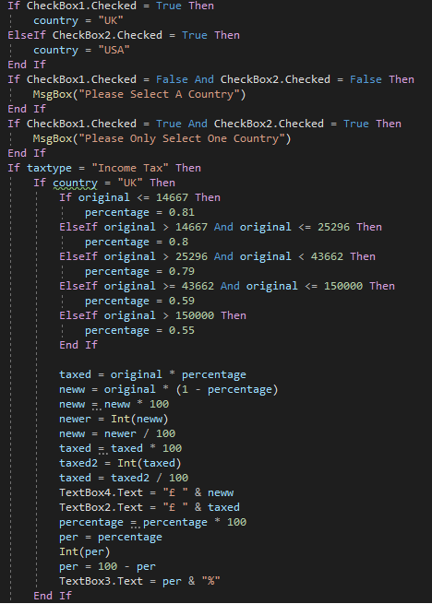

This is the same as before but different fixed rate. This the same algorithm as before. This algorithm is slightly different to the indirect tax one as we need to deduct tax not as it on to the price of a product. This makes it a little less complex overall.

This is the same as before, setting the values, making it smooth ect. But the percentage has a fixed rate

We do the same with the percentage here and we just set all the values not forgetting to add the relevant character stings.

This multiples the amount by the percentage to get the taxed amount, however there is a problem, sometimes you will get for example 19.996 which you can’t have so I have to times it by 100 then int it and divide by 100.

This gathers all the bounds of the taxes and says if the amount is between these bounds we need to do this percentage.

This area and the one below sees which box is ticked and sets a country corresponding to that.

## Identified Bugs and Fixes

|  |  |
| --- | --- |
| Bug | Fix |
| Load up time of the project taking longer due to a few invalid variables. | This is a very easy fix, all I need to do is look at the variables and see how they can be optimised to their task, so this could include getting rid of a few singles and strings. |
| When selected USA and off again on indirect tax the state option doesn’t remove itself. | Yet again an easy fix, it is a big problem so this may be the first to be fixed. All I need to make it so it disappears after deselection. |
| Invalid percentage amount on the USA of VAT. | This one needs to be inverted on the percentage; I may also need to do a bit of tweaking to the algorithm so this could take some time. |
| Bug to do with bot country checkboxes being selected and causing crash. | All I need to do for this one is making it so that if one is selected the other isn’t and set it on a loop throughout the program. |

So far I have identified a few bugs and I have a general idea on how I plan to fix them, although this is talked about more in the conclusion on the next page. Most of these I would plan to fix in the next development update of my project. I will plan to fix the biggest bugs first in order to make the program run as smooth as possible without any major flaws within it.

## Conclusion

|  |  |
| --- | --- |
| Project | Download |
| Built project for straight away use | <https://drive.google.com/drive/folders/1RwHnb_AapK_gv-H0pQVMfpTmv1KD2Lew?usp=sharing> |
| SDK in Visual Studio for a developer | [https://drive.google.com/drive/folders/1Z4ad2CDY3MM](https://drive.google.com/drive/folders/1Z4ad2CDY3MMO700TnEs5v_ummthQRlr_?usp=sharing) |

The software can be very useful in many ways. There is not a whole lot on the market to do your taxes so this is one of the few that could help you to do your taxes easier. What’s more I plan for a lot of development in the future. This could consist of more tax types, more countries, marginal tax and a better-looking user interface. This all makes for a better user experience. I will also attach a link to the download file of both the SDK for the software and the built project file so that a developer or average user can use the software for their own use.

|  |  |  |  |  |
| --- | --- | --- | --- | --- |
| |  | | --- | |  | |  | |  | |  |
|  |  |
|  |  |